**OHIC - Online Home Inspection Checklist**

Members: Paulette Fenderson, Kyle Brittan, Miriam Armada, Chay Dahill

Team Name:

Project Description:

OHIC will be a website for home inspectors that provides an up to date checklist for inspecting homes.  It will have a checklist that incorporates Google Spreadsheets that can be updated at any time. If the inspector checks that an item does not meet expectations they will see a text box appear in which they can provide information about the item.  The website will also incorporate FlexMLS or Zillow data to provide the inspector easy access information about the house such as how many bathrooms and types of appliances to expect. This will let the inspector be better prepared for the upcoming inspection.

Sketch of Final Product:

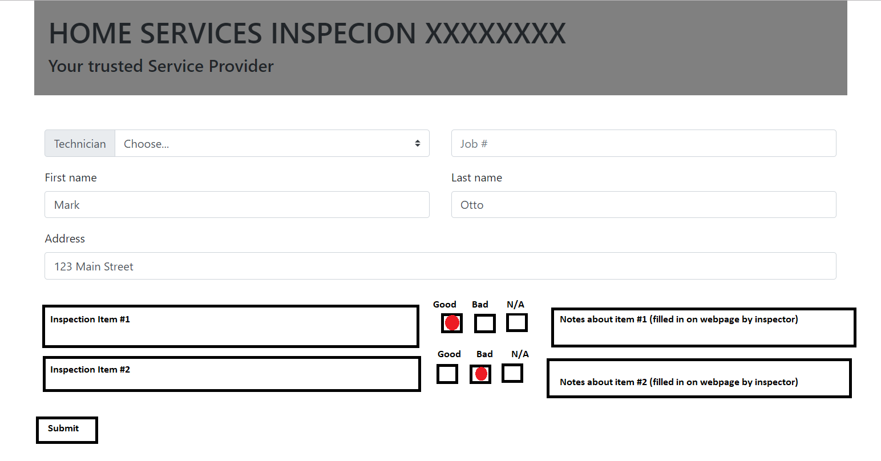

APIs to be used:

Google Spreadsheets API - take the information from Google spreadsheets and put on the website so that it uses the same html and styling as the rest of the website.  This will create a clean looking checklist that can be easily updated by somebody who does not have web development experience.

Zillow API - provides details and pictures of the house that might be useful for the inspector such as types of appliances, types of utilities, number of rooms, etc.

Rough breakdown of tasks:

~~Create Github - Paulette (done)~~

HTML - Paulette

Customer information form

CSS/Bootstrap - Paulette / Miriam

Firebase database - Kyle

Create

Submit to database

APIs -

Learn and implement Google Spreadsheets API - Chay

Learn and implement the real estate API - Miriam

Put pictures where needed - Miriam

JS - Team

Create a checklist radial buttons (yes, no, n/a) for each row of spreadsheet

“No” button should make a notes field appear

Submit to “company” database and email to customer